**Model Comparisons**

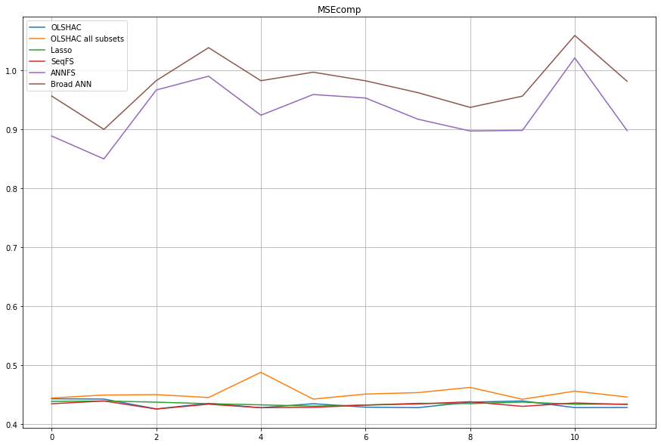

**Feature Selection Bar Graph**

